Step 1: download Power BI.

Step 2: Click on Blank Report.

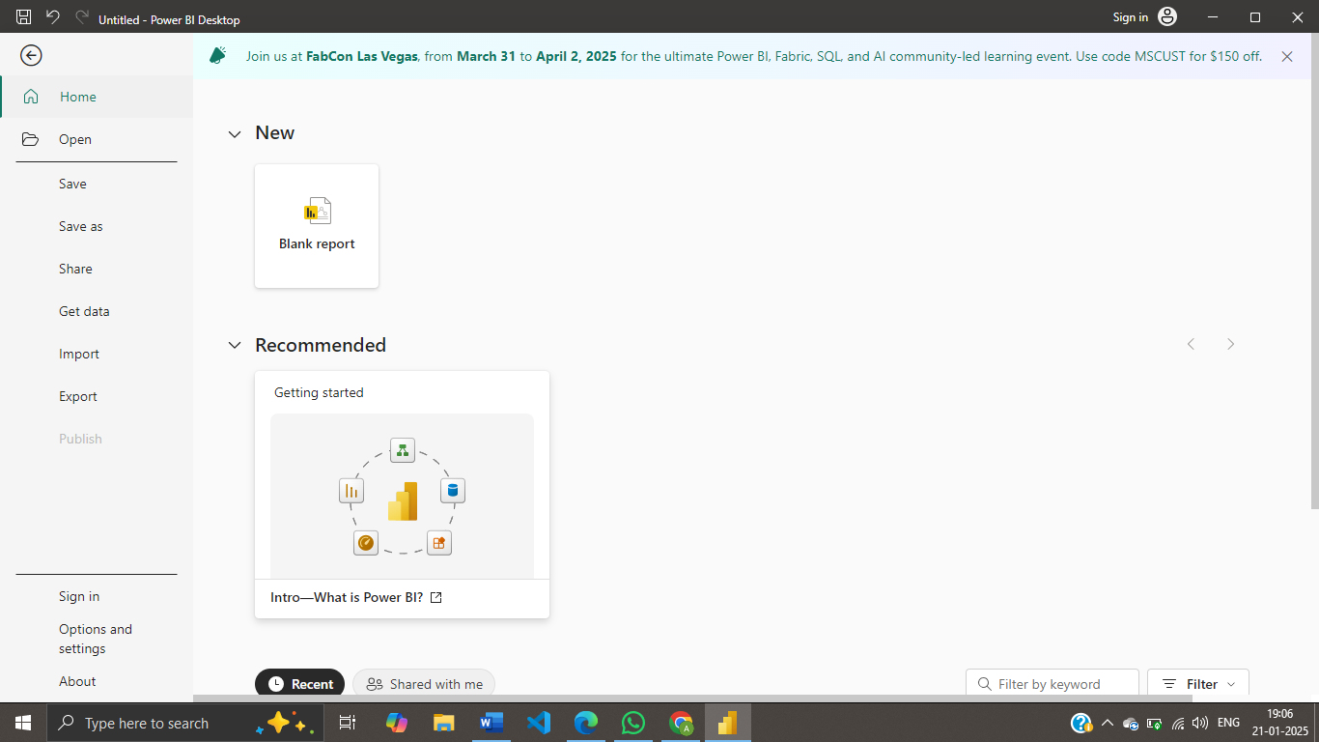

Step 3: To extract data, click on Get data. Then go to Test/CSV. 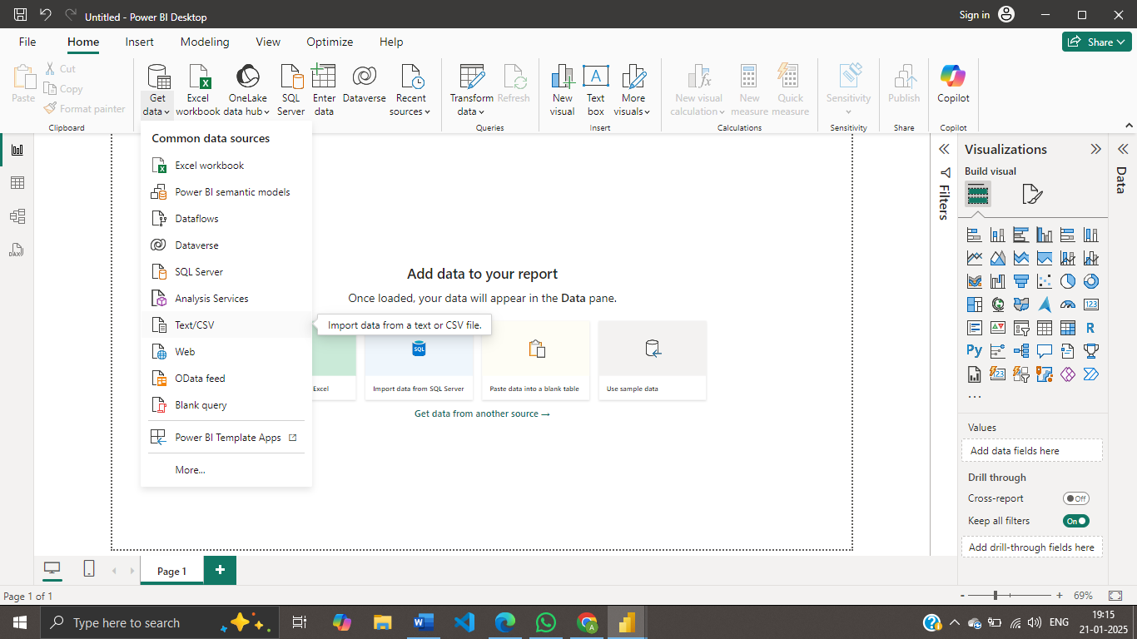

Step 4:select the file and click open.

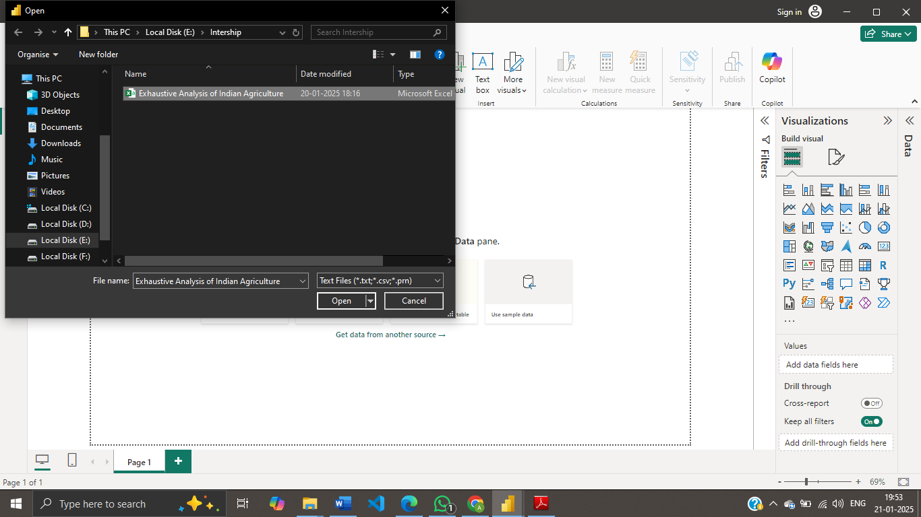

Step 5: Select Load when data is cleaned or select Transform when we have to process the data or clean them

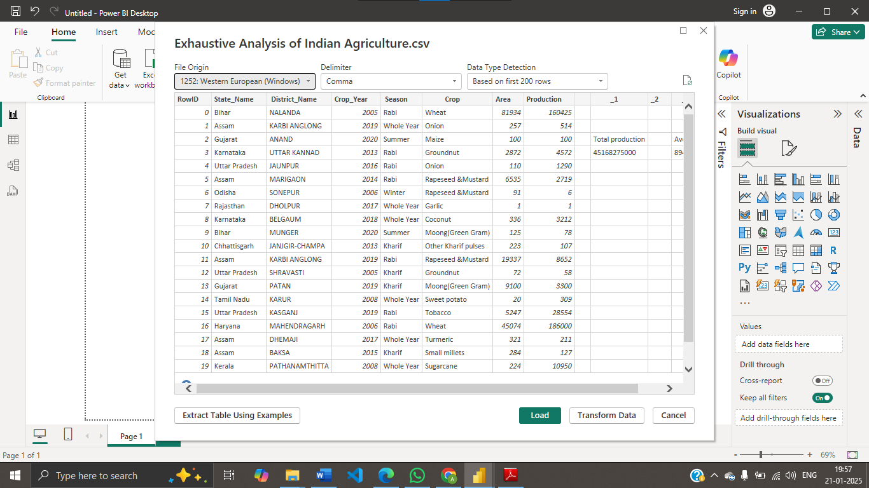

Step 6:Select the Row, right click and select Remove.

Do the same for all unnecessary columns.

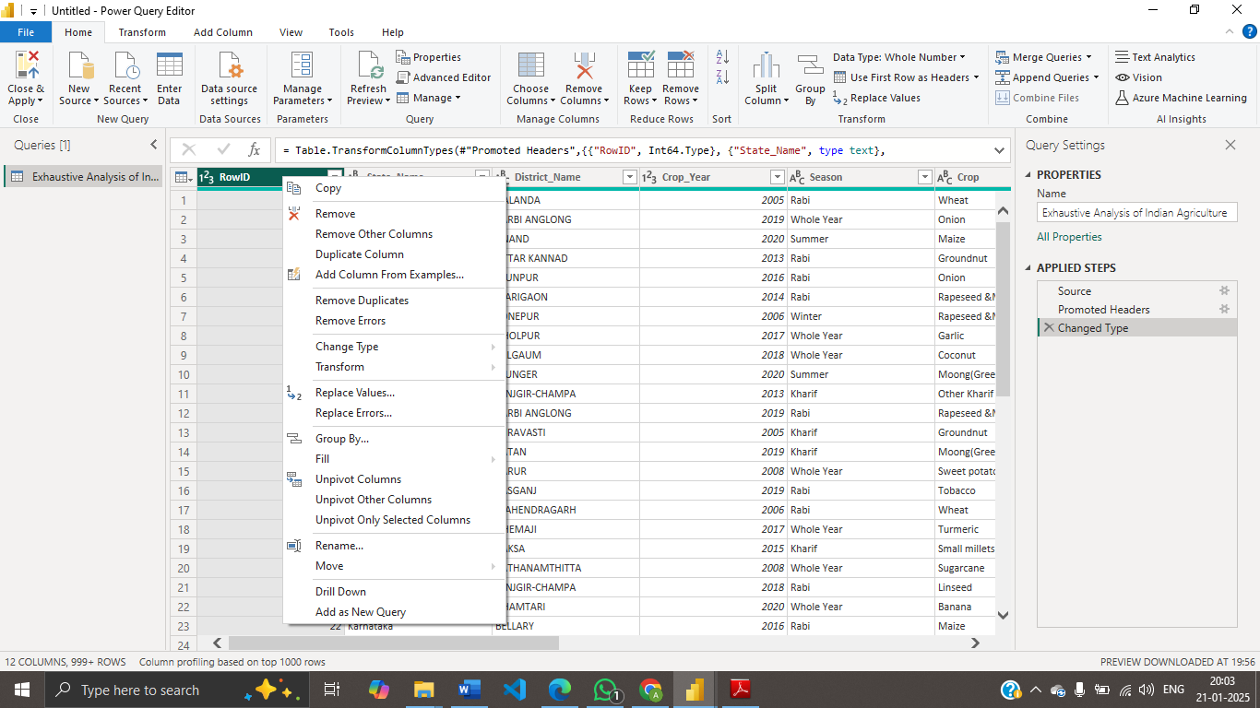

Step 7: To check whether we have null values or not.

Select View option .

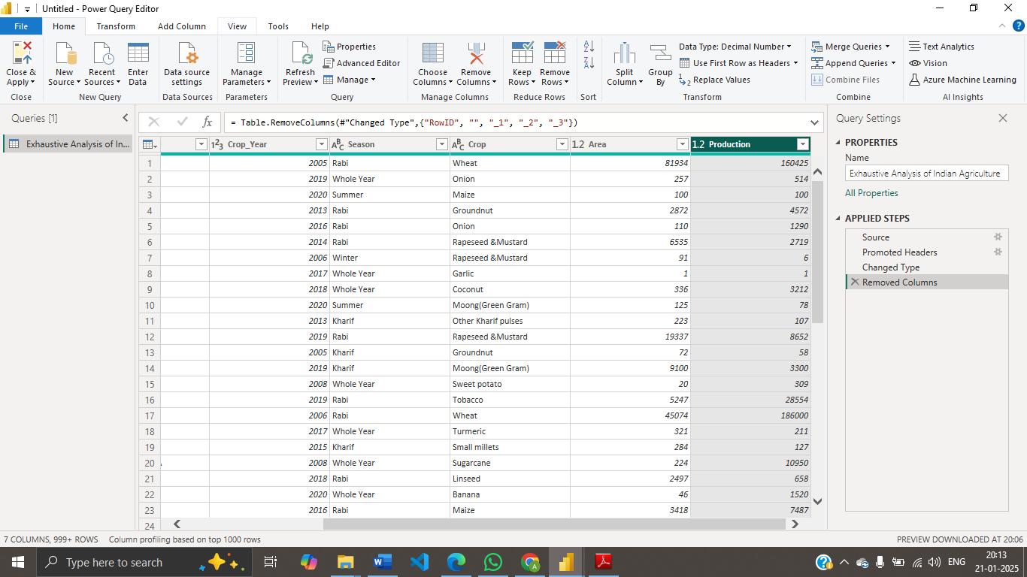

Step 8: select column quality. In empty , it shown whether we have null values or not.

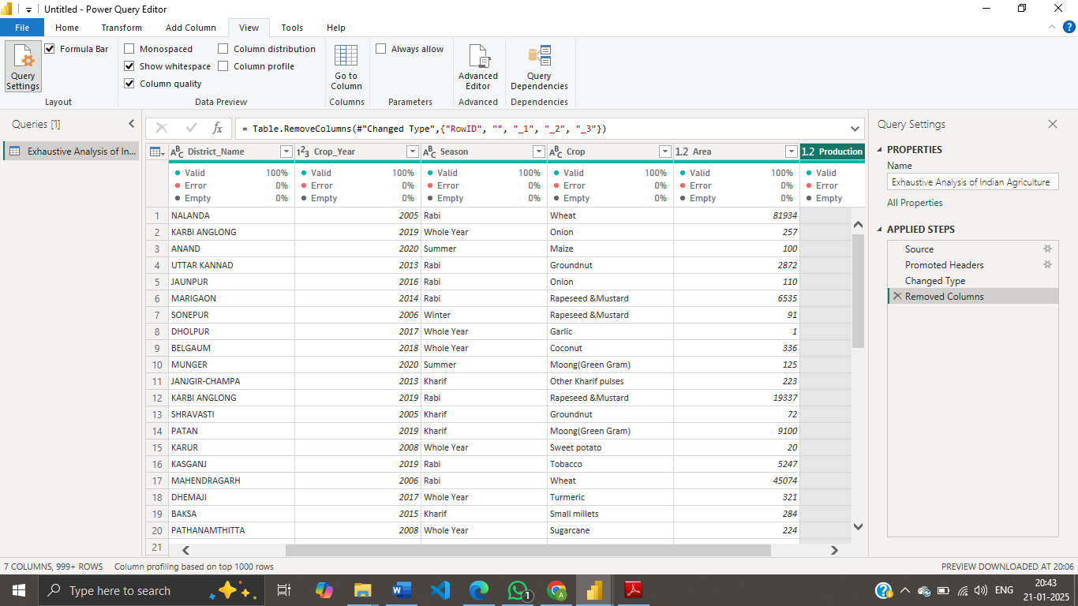

Step 9: Go to home page, select Remove rows and then click on remove duplicate

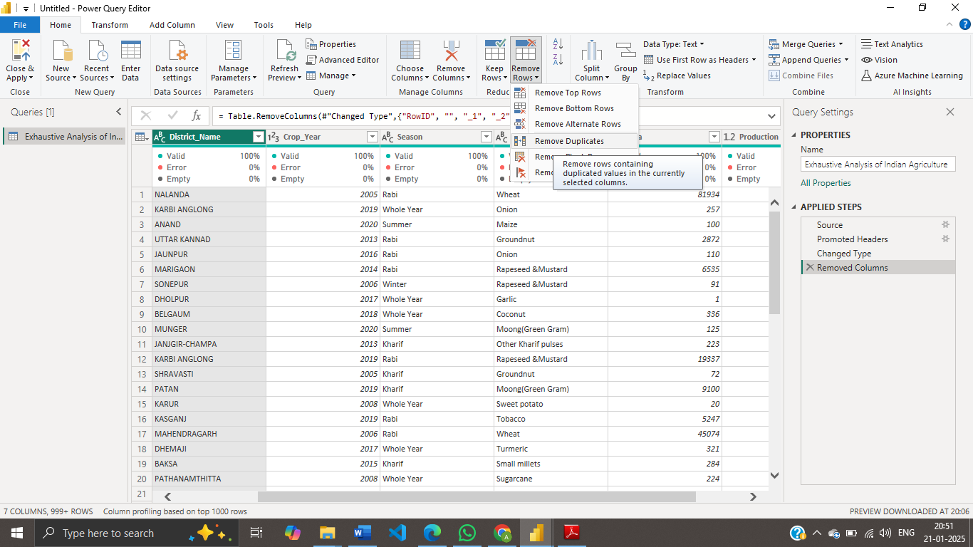

Step 10: To save, select close and apply then click close and apply.

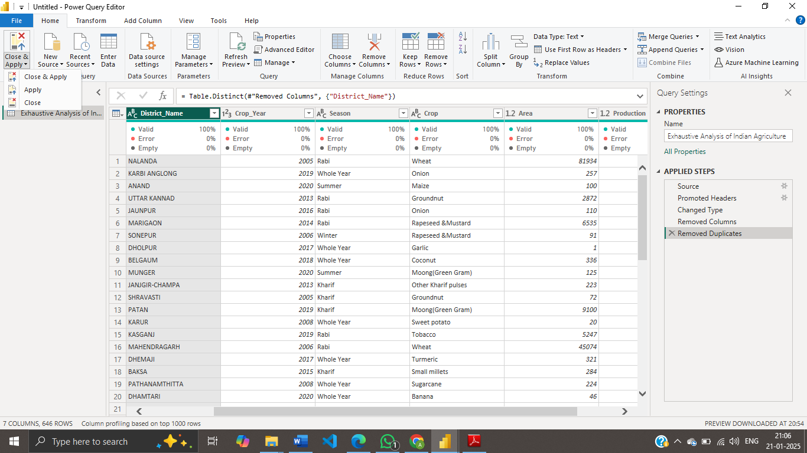

Step 11: click Table view in the left side of power BI desktop.

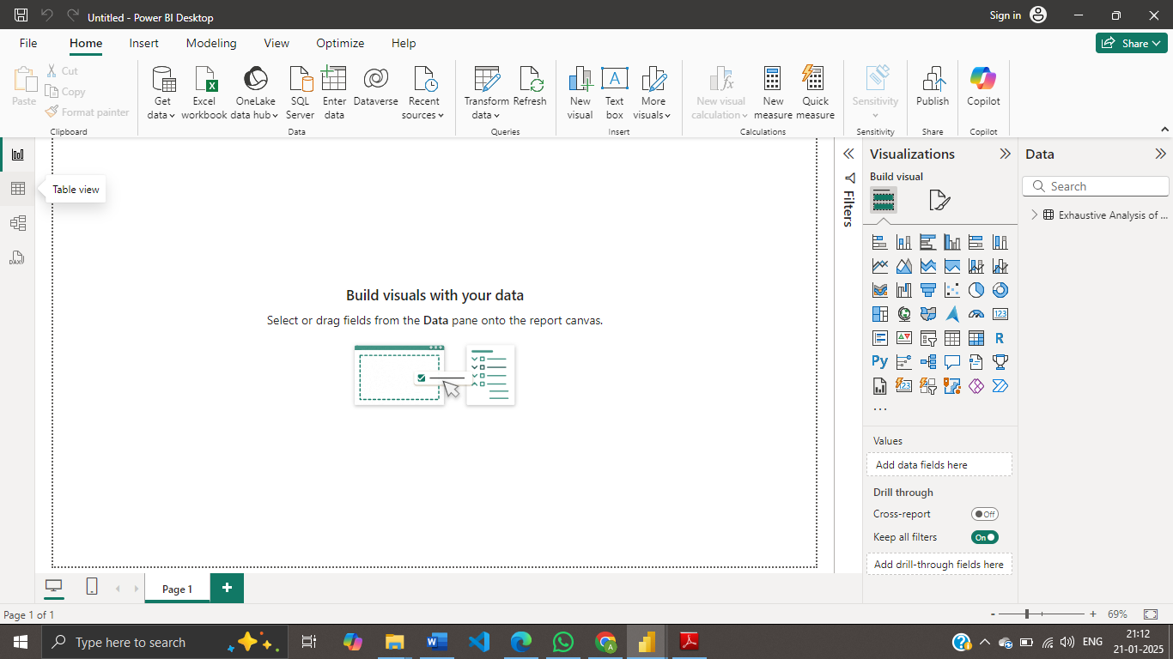

Step 12: This the final table